1. **Tell me about yourself?**

Good morning/afternoon! Thank you for this opportunity.

My name is Chilukuri Mallikharjun Reddy, and I recently graduated in 2024 from Lakireddy Balireddy College of Engineering, where I pursued a degree in Electronics and Communication Engineering. During my studies, I developed a strong foundation in programming and problem-solving, with proficiency in languages like Java, C, C++, and Python. Recently, I have also started exploring web development, which I find exciting and innovative.

I enjoy working on mini projects that challenge my technical skills and allow me to apply my knowledge practically. Outside of academics, I’m passionate about playing cricket, which helps me stay active and develop teamwork skills. I’m always eager to learn new things, whether it’s a new technology or a fresh perspective, and I believe this adaptability will help me contribute effectively to any team or project I’m a part of

1. **What motivates you?**

**Answer Tip:** Emphasize your enthusiasm for learning, growth, and contributing to the team.

**Example:** "I am motivated by the opportunity to learn and grow, both professionally and personally. I enjoy taking on new challenges and finding innovative solutions. I am excited about developing my skills and contributing to the success of the company."

1. **What are your strengths?**

**Answer Tip:** Choose strengths that are relevant to the job, such as communication, problem-solving, or technical skills, and provide examples of how you’ve demonstrated them.

**Example:** "One of my strengths is my ability to learn quickly. During my time at university, I picked up new programming languages and tools on my own through online resources and projects. I’m also a good communicator and work well in team settings."

1. **What is your greatest weakness?**

**Answer Tip**: Be honest, but frame it as something you’re working on improving.

**Example:** "I tend to be a perfectionist at times, which means I can spend too much time ensuring every detail is perfect. However, I’ve learned to manage this by setting clear priorities and focusing on delivering results on time."

1. **How do you handle challenges or stressful situations?**

**Answer Tip**: Show that you can stay calm, think critically, and seek solutions, even if you don’t have direct work experience.

**Example:** "When I encounter a challenge, I break it down into smaller, more manageable tasks. I stay calm and focus on finding a solution rather than getting overwhelmed. During a group project in college, we had tight deadlines, and I helped organize tasks to ensure everyone was on the same page, which allowed us to meet our goals."

1. **Where do you see yourself in 5 years?**

**Answer Tip**: Focus on your desire to grow and contribute to the company, while being flexible in your career path.

**Example:** "In five years, I see myself having developed my technical skills and taking on more responsibility. I would like to be in a position where I can contribute to more significant projects and help guide new team members, but I’m open to exploring different opportunities that will help me grow within your company."

1. **How do you prioritize tasks when you have multiple deadlines?**

**Answer Tip**: Show your ability to stay organized and focused, even if you haven’t faced this challenge in a job setting yet.

**Example:** "I use time management techniques, such as making to-do lists and breaking tasks into smaller chunks. I prioritize based on deadlines and the complexity of the tasks, making sure to focus on one task at a time to ensure quality. In college, I often had overlapping deadlines, and this method helped me manage my workload effectively."

1. **What is the difference between confidence and over confidence?**

Confidence is something that makes you believe that you can do a particular thing whereas when overconfidence comes into play it makes you believe that only you can do a particular thing & no one else is capable as you are.

1. **Difference Between Hard Work and Smart Work?**

Hard work is putting in a lot of effort to complete a task, often figuring things out as you go. Smart work is planning and finding the easiest and most efficient way to do the task before starting.

1. **Can you work under pressure?**

Yes, I can work under pressure. I believe that just like pressure turns coal into diamonds, it can bring out the best in us. For instance, during my college days, I had to complete a major project while preparing for exams. By staying focused, managing my time effectively, and maintaining a positive mindset, I was able to excel in both. I see pressure as an opportunity to grow and deliver my best work.

1. **Are you willing to relocate or travel?**

Yes, I’m open to relocating or traveling if the role requires it. I see it as an opportunity to grow personally and professionally while contributing to the company's goals. I’m excited about the chance to experience new environments and take on new challenges.

1. **How long would you expect to work for us if hired?**

I would be honoured to work for your company if I get the opportunity. I believe this company offers great growth opportunities for employees. I see myself being a part of this organization for several years, where I can build my career and grow both personally and professionally.

1. **About Accenture:**

Accenture is a leading global professional services company that helps the world’s leading businesses, governments and other organizations build their digital core, optimize their operations, accelerate revenue growth and enhance citizen services—creating tangible value at speed and scale. We are a talent- and innovation-led company with approximately 743,000 people serving clients in more than 120 countries. Technology is at the core of change today, and we are one of the world’s leaders in helping drive that change, with strong ecosystem relationships. We combine our strength in technology and leadership in cloud, data and AI with unmatched industry experience, functional expertise and global delivery capability. We are uniquely able to deliver tangible outcomes because of our broad range of services, solutions and assets across Strategy & Consulting, Technology, Operations, Industry X and Song. These capabilities, together with our culture of shared success and commitment to creating 360° value, enable us to help our clients reinvent and build trusted, lasting relationships. We measure our success by the 360° value we create for our clients, each other, our shareholders, partners and communities.

1. **Do you have any questions for us?**

Yes, I do have a few questions.

1. If I am selected for the role, could you please share which technologies I would be working with?
2. How does the training process work after joining, and what kind of support does Accenture provide to help employees grow and learn new skills?

**PROJECTS**

* 1. **Gas Leakage Detector**

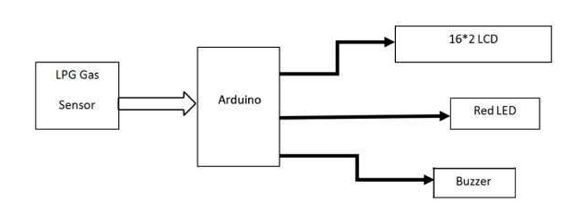In my third year of B.Tech, I worked on a community service project titled Gas Leakage Detector to address the dangers of gas leaks in homes, which can lead to property damage and loss of lives. The system used an Arduino Uno programmed in C, a gas sensor to detect leaks, a buzzer and danger light for alerts, and an exhaust fan to disperse the gas. One challenge we faced was testing in real-world conditions, as carrying gas for experimentation was unsafe, requiring creative simulation techniques. This project gave me hands-on experience in programming microcontrollers, interfacing hardware, and designing safety solutions, making it a meaningful and impactful experience in community service.

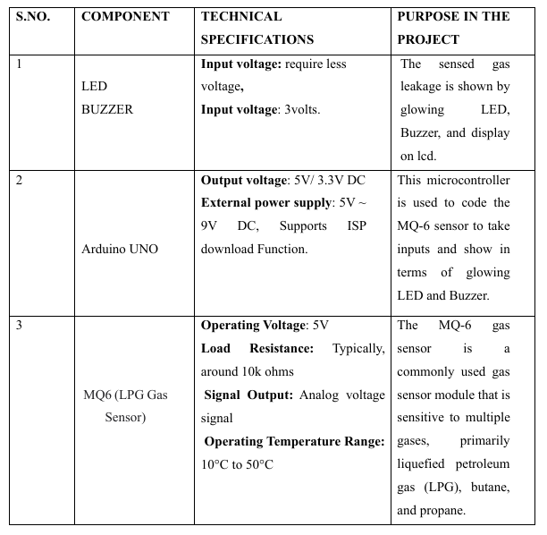

**2. Design and Analysis of Dual Band Patch Antenna for Wireless Applications**

In my second year of B.Tech, I worked on a project titled Design and Analysis of Dual Band Patch Antenna for Wireless Applications. I used the Ansys HFSS simulation tool to design the antenna. One challenge I faced during the design process was obtaining the correct design to achieve specific frequencies. The proposed antenna was designed to be suitable for wireless applications, specifically for the X-band (8-12GHz). This project gave me a deeper understanding of antenna design and the importance of frequency matching for wireless communication systems.

* A white sheet with black text

  Description automatically generatedFR4 EPOXY dielectric material is selected which is having dielectric constant of 4.4
* Iteration (3) is from 8.2 GHz to 9.6GHz

1. **Student Database Management System using C++**

In my final year, I developed a project titled Student Database Management System during my free time, using C++. The system was designed to manage student data such as creating, accessing, updating, deleting, and searching records. I used OOPs concepts to build the system and files for data storage. During this project, I gained a better understanding of OOPs principles in C++ and learned the importance of proper coding practices for maintaining clean and understandable code.

1. **Basic Banking System using C**

It was a small project that I developed after our class was cancelled one day, titled Basic Banking System using C. In this project, I implemented functionality to access the user's bank balance and transaction history using linked lists and dynamic memory allocation.

1. **Implementation and Analysis of 6-Transistor SRAM Cell**

My final year project was titled Implementation and Analysis of 6-Transistor SRAM Cell, implemented using Cadence software in 45-nanometer technology. In this project, we designed the 6-transistor SRAM cell and analysed its power consumption, delay characterization, layout design, and area. While developing this project, we faced numerous challenges in design, software, and analysis. We also learned a great deal about designing in Cadence, power calculations, layout area calculations, and the importance of teamwork during crucial stages of the project.

**MOTIVATION FOR THE PROJECT**

The reason for working on the 6-transistor SRAM cell project could be to make memory storage in electronics better. We want to make accessing data faster, use less power, and make the most of the space on the chip. Also, as technology improves, people want smaller, faster, and more efficient devices, so we're exploring new SRAM designs like the 6-transistor cell. Another reason could be to solve problems with making transistors smaller and reducing power loss in modern technology. Overall, the aim of the project is to create memory solutions that work better and meet the changing needs of different electronic devices.

**OBJECTIVES FOR THE PROJECT**

**Performance Enhancement:** Improve the speed and efficiency of data access and storage operations compared to existing SRAM designs.

**Power Efficiency:** Reduce power consumption while maintaining reliable operation, making it suitable for energy-efficient devices.

**Area Optimization:** Minimize the physical footprint of the SRAM cell on the semiconductor chip to maximize integration density.

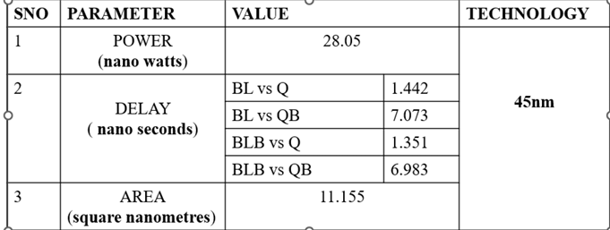**Process Compatibility:** Ensure compatibility with the 45nm CMOS technology node for seamless integration into modern semiconductor manufacturing processes.

For my final year project, I worked on the **Implementation and Analysis of a 6-Transistor SRAM Cell** using **Cadence software** in **45-nanometer technology**. As a part of this project, my team and I designed the SRAM cell and performed a detailed analysis of its power consumption, delay characterization, layout design, and area.

While working on the project, we faced several challenges, particularly with the design, software issues, and analysis. Despite these difficulties, I played a significant role in overcoming them, especially when we encountered issues with our team leadership. Initially, I was a team member, but due to some challenges with the original team leader, I took the initiative to step up and lead the team through the remaining phases of the project. While the formal leadership title remained with the original leader, I took on substantial responsibilities, including **task coordination**, **team management**, and ensuring that we adhered to deadlines.

Throughout the project, I gained in-depth knowledge of **Cadence software**, **power calculations**, and **layout area analysis**, and developed a better understanding of the importance of teamwork in overcoming challenges. My leadership during the crucial stages helped the team stay on track and ensured the timely completion of the project.

This experience not only enhanced my **technical skills** in design and analysis but also helped me develop essential **leadership**, **communication**, and **problem-solving skills**. It was an invaluable experience that shaped my approach to project management and teamwork in complex technical environments.

